Requirement Analysis(3)

StaffSync Data Flow and User Stories
Team ID | Not assigned — individual project
Project Name | StaffSync
Maximum Marks | 4 Marks
Prepared by Abhigyan Dwivedi · Individual capstone
Data flow diagrams
The context diagram shows HR, Employee and Manager exchanging requests and results with StaffSync. The internal flow retains one React frontend, Express REST API and MongoDB through Mongoose.
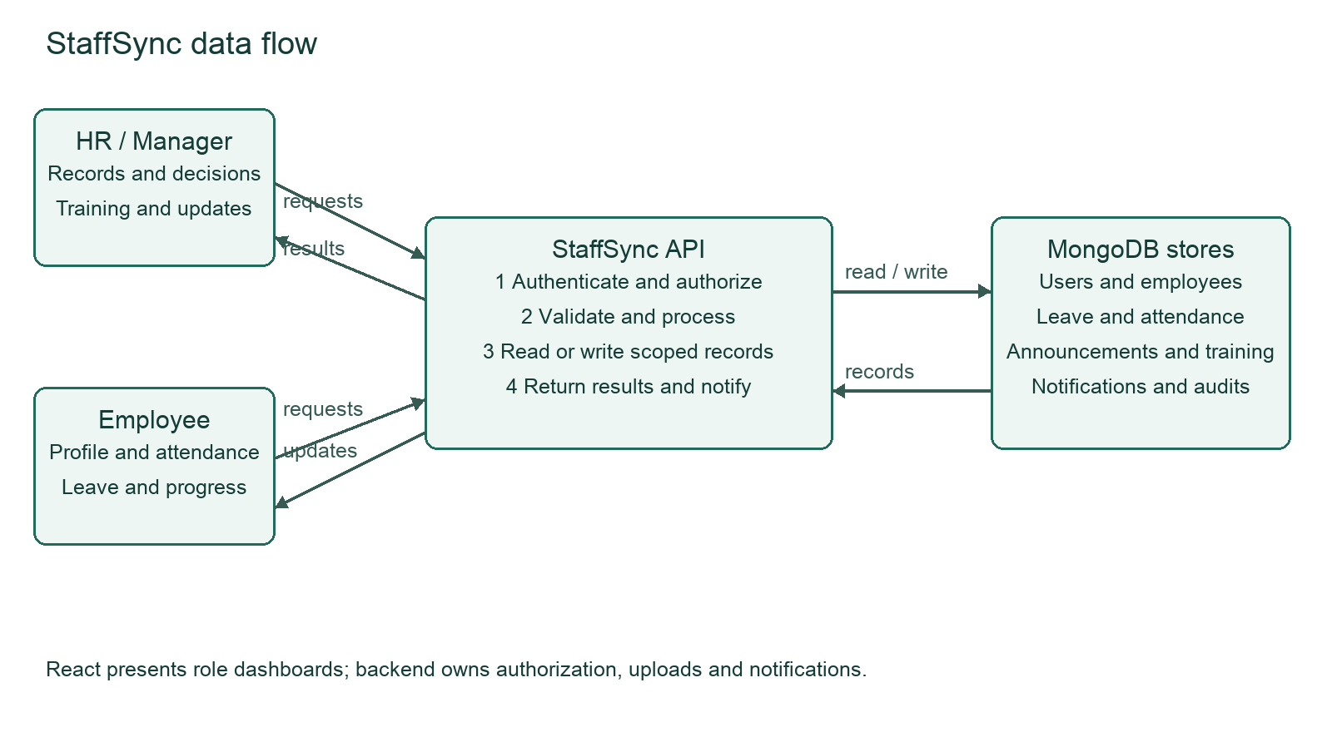
User stories and acceptance criteria
Role | Epic | Story | Acceptance criteria
All | FR-1 | Register and log in with a role | Valid account opens permitted dashboard; invalid credentials fail
HR | FR-2 | Maintain employee information | Authorized edits persist; employee cannot perform HR operations
Employee | FR-3 | Mark daily attendance | One check-in and check-out per organization day
Employee | FR-4 | Request leave | Invalid dates and overlapping active requests fail
HR or Manager | FR-4 | Decide a leave request | HR or assigned manager can decide; unrelated manager cannot
HR or Manager | FR-5 | Post announcements | Only authorized authors publish; audience filters apply
Manager | FR-6 | Assign training | Only own team members can be assigned
Employee | FR-6 | Record training progress | Own assignment changes; response minimization remains a known issue
HR | FR-6 | Export attendance | Authorized report produces CSV with selected data

Data stores: User credentials and roles; Employee profiles and manager links; LeaveRequest decisions; Attendance dates and times; Announcement audiences; TrainingProgram assignments. Notification recipient links and Audit events support these workflows. Database secrets stay in server environment variables.

